Prerequisite.

Only 2 prerequisites are necessary to operate with the ASME Unit, the first one is the Hw Tool that will be connected to the ASME trough the Serial Wire Debug (SWD) Port; the second is the Sw IDE that could be used both to create the code and debug it in conjunction with the Hw Tool .  
The Sw tool is totally free, while the 2 Hw Tools have a very limited cost, around 100$.

Hw prerequisite:

1. Atmel-ICE is a powerful development tool for debugging and programming Atmel ARM® Cortex®-M based Atmel SAM and AVR® microcontrollers with on-chip debug capability.  
   More information on the Atmel-ICE home page (<http://www.atmel.com/tools/atatmel-ice.aspx>).
2. Alternately it is possible to use the Atmel SAM-ICE .  
   Atmel SAM-ICE™ is a JTAG emulator designed for Atmel SAMA5, SAM3, SAM4, SAM7 and SAM9 ARM® core-based microcontrollers, including the Thumb® mode.  
   More information on the SAM-ICE home page(<http://www.atmel.com/tools/ATMELSAM-ICE.aspx>).

## Sw Prerequisite:

1. Atmel® Studio 6 is the integrated development platform (IDP) for developing and debugging Atmel ARM® Cortex®-M and Atmel AVR® microcontroller (MCU) based applications.

It is fully downloadable from the Atmel Studio6 home page, after a free registration to the Atmel network. (<http://www.atmel.com/microsite/atmel_studio6/>)

# Environment setup

## HW Tool Setup

HW Setup isn’t necessary, as it is ready to use.

The system will automatically detect if a new FW is present for the HW at the first connection (more in the Debugging session chapter)

## SW Tool Setup

First of all it is necessary to download the SW: go to the Home page (<http://www.atmel.com/microsite/atmel_studio6/>) and press the “Download Now” button.

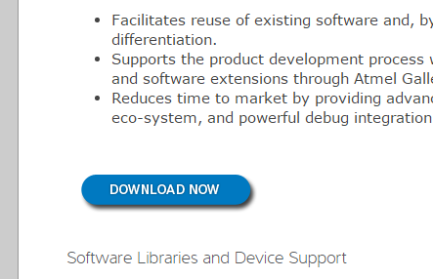

You will be redirected to the page where it is possible to download the Sw (select the disk icon).  
There are 2 choices: with or without “.NET”.   
Considering that the Studio6 needs .NET to work, you should download the full package if the host pc does not have .NET

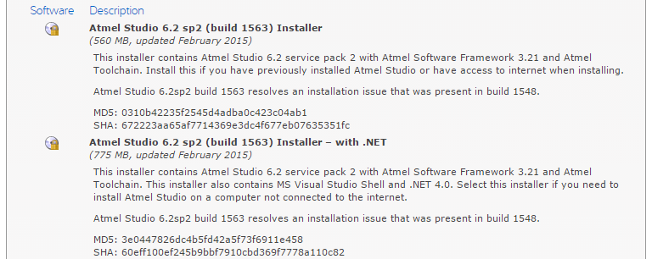

## Clicking on the correct disk icon you will land on the Atmel subscription form (useful to activate many other downloads, such as examples or add-ons of Studio6), but it is also possible to download the SW as a guest user.

When the setup file is on your pc, run it and follow the few steps required for a complete installation of the Sw tool.

## SW example Installation

The example Sw is downloadable trough GitHub on (<https://github.com/axelelettronica/ArrowHandsOn>) by pressing the “Download Zip” button.  
**It is not required to be subscribed to GitHub.**

The zip is completed with source and project file for Atmel Studio 6.  
The Software has a GNU license, this means that everyone could download and use.

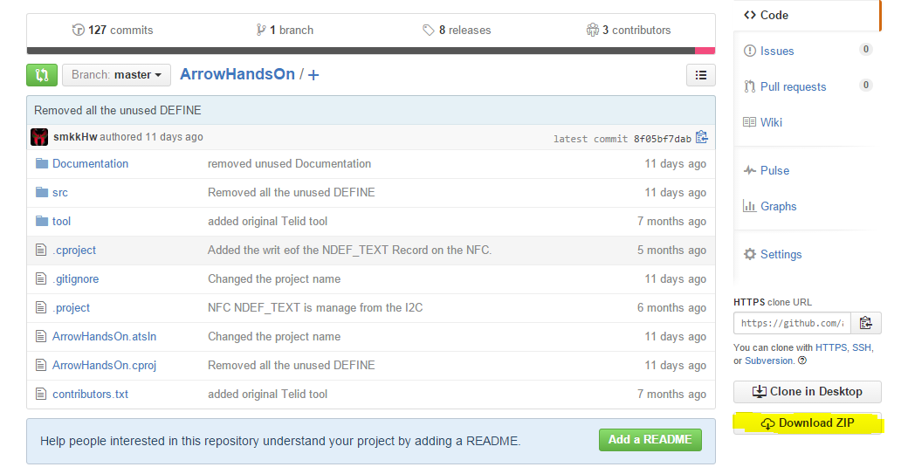

Unzip it on a directory, it is suggest to use the default Studio6 project directory, which normally is under “**C:\Users\<pc user>\Documents\Atmel Studio**”, but it is not required and could be unzipped on any yours preferred directory.

# Code explanation

Spiegare a grandi righe come funziona il codice

## FreeRtos tasks

Spiegare I task principali

## Startup

Spiegare la modalita’ di inizializzazione di tutti I componenti

## Button pressed

Spiegare cosa succeed quando si preme il pulsante

# Atmel Studio 6 Project open

Run Atmel Studio6 application on your PC (if it will require to download the new Framework, skip that part for this example).

After the splash screen it will be show the “**Start Page**” of the IDE.  
Select “**Open Project…**”andgoes to the directory on where did you unzip the example (do nothing if you choose the Atmel Studio6 default directory).

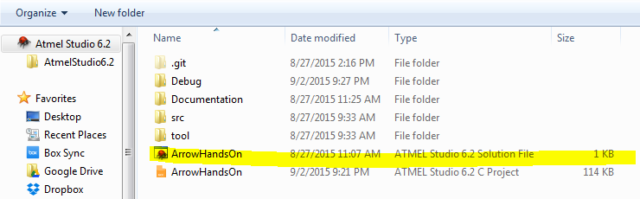

Select the file “**HarrowHandsOn** … **Solution File**” (the one with the Studio6 Icon)

Finally you have the Sw ready for changes or debugging.

The IDE is divided in many frames in different position; the most important are the right and the left one, on which are visible the source frames and the project frame.

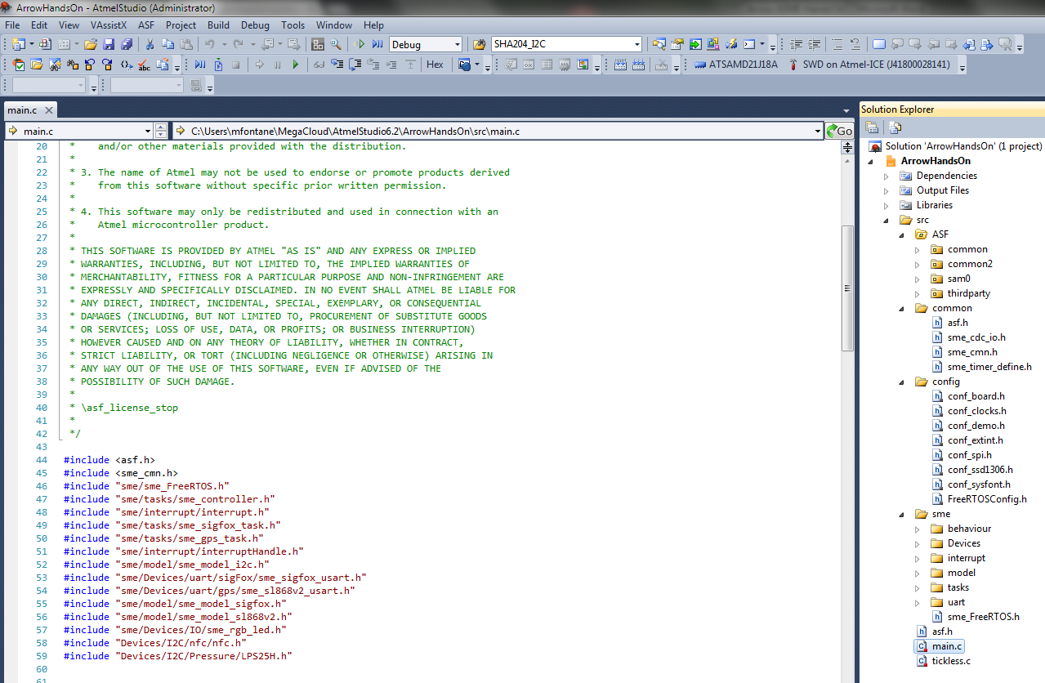

# Atmel Studio 6 Project Compiling

To compile the SW, before download it on the ASME, there are two ways:  
1) Build Solution  
2) build project  
For this examples both are identical, just use build project which is more correct.  
Build solution is for those complex projects that require to be split in more small projects.

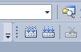

Any Blocking Errors or simple Warning will be listed on the bottom frame.

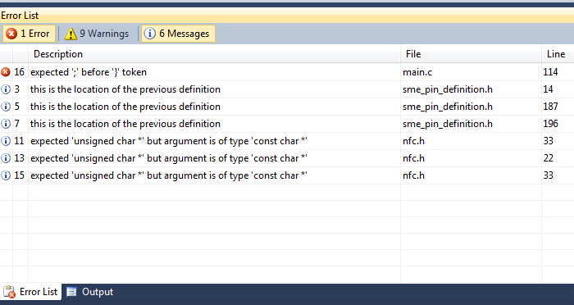

# Atmel Studio 6 Debugging session

## Hw connection

**ATTENTION !!!!!!!** the SWD has a not polarized connector, this means that it could be possible to insert the cable on the wrong side. The red wire shall be connected to pin1

Fare foto per corretta polarizzazione del SWD

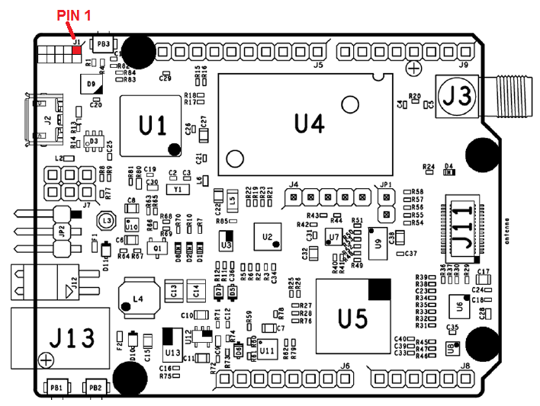

Premere il bottone del play.

Il Sistema fara apparire la pagina del progetto chiedendo che tipo di debugger si vuole utilizzare.

Selezionare il proprio HW (SAM-ICE or Atmel-ICE), solo la prima potrebbe essere che verra’ chiesto il download del nuovo FW, dare il consenso ed aspettare la fine del download.

# Prepare ASME to work with Arduino IDE

It is possible to use the ASME in Arduino mode, in this case it will be programmed in the identical way like all the others Arduino units, no Atmel Studio6 is required, instead, the new Arduino is needed.

Prerequisite is to have the Arduino Ide Ide (Ver 1.6.5 or newer) and the SmartEverything core already installed and the ASME user guide well describe how to do.

It is no part of this Hands On going deeper in detail of the Arduino IDE, just see the fundamental step to prepare the ASME to work with the Arduino IDE.  
This step consist to download the Arduino bootloader into the ASME, to do this we still need the Atmel-ICE for the last time, as soon the bootloader is resident on the flash a direct connection trough the USB is sufficient to download the code from the IDE.

Open the Ide and select, from menu, the “Tool” item, the :  
1 )Select the ATMEL-ICE as programmer  
2) Select SmartEverything Fox (via ATMEL-ICE) as Board  
3) Now select Burn Bootloader

After the reset the ASME is ready to be programmed via USB with the Arduino IDE.

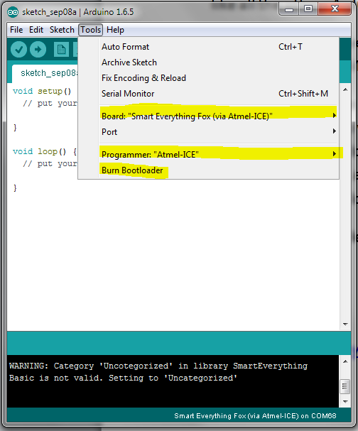

# References

Asme Web Site   
(<http://www.smarteverything.it/>)

### Asme User Guide v. 1.0 (<http://www.smarteverything.it/?smd_process_download=1&download_id=1798>)

Atmel Studio6  
(<http://www.atmel.com/microsite/atmel_studio6/>)

Arduino Home Page  
(<https://www.arduino.cc/>)